1 – Literary Quotations - creating a class and method invocation

- Create a class to print to screen some famous quotes.
Quotes
+ ShakespeareQuote()
+ OscarWildeQuote()
+ ChurchillQuote()
+ GeorgeWBush()

- The output of the program when you invoke each method should be...

- Update your program to include the following quote …
“If the facts don't fit the theory, change the facts. Albert Einstein”
- Test your program again.

2 – Simpsons


Create the following class to represent a Simpsons character in an application.
SimpsonsCharacter
- name
- catchPhase
+ getName() : String
+ setName(String name)
+ getCatchPhrase() : String
+ setCatchPhrase(String catchPhrase)
+ sayCatchPhrase() : void

Create another class CartoonApp.java to create each following characters. (It should have a main method).
Character name | Catch phase
Bart | Eat my shorts!
Homer | D’Oh!
Lisa | I’ll be in my room
Nelson | HaHa

For each of the character objects set the appropriate instance variables, e.g. for the Bart character set the Name to “Bart” and the Catch Phase to “Eat my shorts”. Then for each character object in turn invoke the sayCatchPhrase method. The sayCatchPhrase method should output to screen …
<CharacterName> says <CatchPhrase>
So the output to screen should show ….
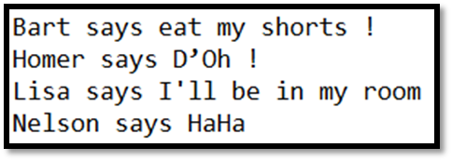
3. Car factory - creating classes.

OO Examples
- Create a Java class to represent a Car. It should have the following properties (state) and methods (behaviour).
State
Make
Model
Colour
Number of doors
Engine size
Max speed
Started
Methods
It should be possible to start the car (i.e. create a method that confirms the car is started – output to screen) and stop the car (also a method that outputs that the car is stopped). These methods should be able to read and alter the Started property
Represented in a UML class diagram…

Car
- Make : String
- Model : String
- Colour : String
- Number of doors : int
- Engine size : double
- Max speed : int
- Started : boolean
Prints to screen all the car details

+ startCar()
+ stopCar()
+ displayAll()

- Create each car with the specification details as detailed above and output the properties to screen.
Make | Model | Colour | Doors | Engine Size | Max speed
Ford | Fiesta | Blue | 4 | 1.2 | 110
Peugeot | 308 | Silver | 4 | 1.8 | 130
Ferrari | F4 | Red | 2 | 2.8 | 230

.

Part 4 – Calculator - creating classes – invoking methods with parameters

- Create a class to represent the operations of a basic calculator. All methods should display output directly to screen.
For example ..
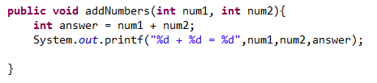
Calculator
- memory : int

+ addNumbers(num1 : int, num2 : int)
+ substract(num1 : int, num2 : int)
+ multiply (num1 : int, num2 : int)
+ divide(num1 : int, num2 : int)
+ squareRoot(num1 : int)
+ randomNumber()
+ addToMemory(num1 : int)
+ recallFromMemory()
+ clearMemory()

- Create an instance of the calculator and test all the functions. Typically a class in Java is tested by the author using an automated test program (e.g. JUnit). We will be doing this later in the course but test using test specification like this …
Test Case | Test description |  | Test data | Expected outcome | Test results (screen capture or observed outcome)
1.1 | Testing the addNumbers method. Two numbers will be passed to the method and the answer checked against the expected answered. |  | Num1 = 3  Num2 = 4 | Answer should be displayed as 7
1.2 | Etc
….
Part 3 – Calculator update - invoking methods with return types

- The calculator class requires several updates. Some methods now require the output to be returned rather than displayed directly on screen
FunCalculator
- Memory : int

+ addNumbers(num1 : int, num2 : int) : int
+ substract(num1 : int, num2 : int) : int
+ multiply (num1 : int, num2 : int) : int
+ divide(num1 : int, num2 : int) : double
+ squareRoot(num1 : int) : double
+ randomNumber() : int
+ addToMemory(num1 : int)
+ recallFromMemory() : int
+ clearMemory()

- Update the class and test again.

